Falkirk Branch Booking Form
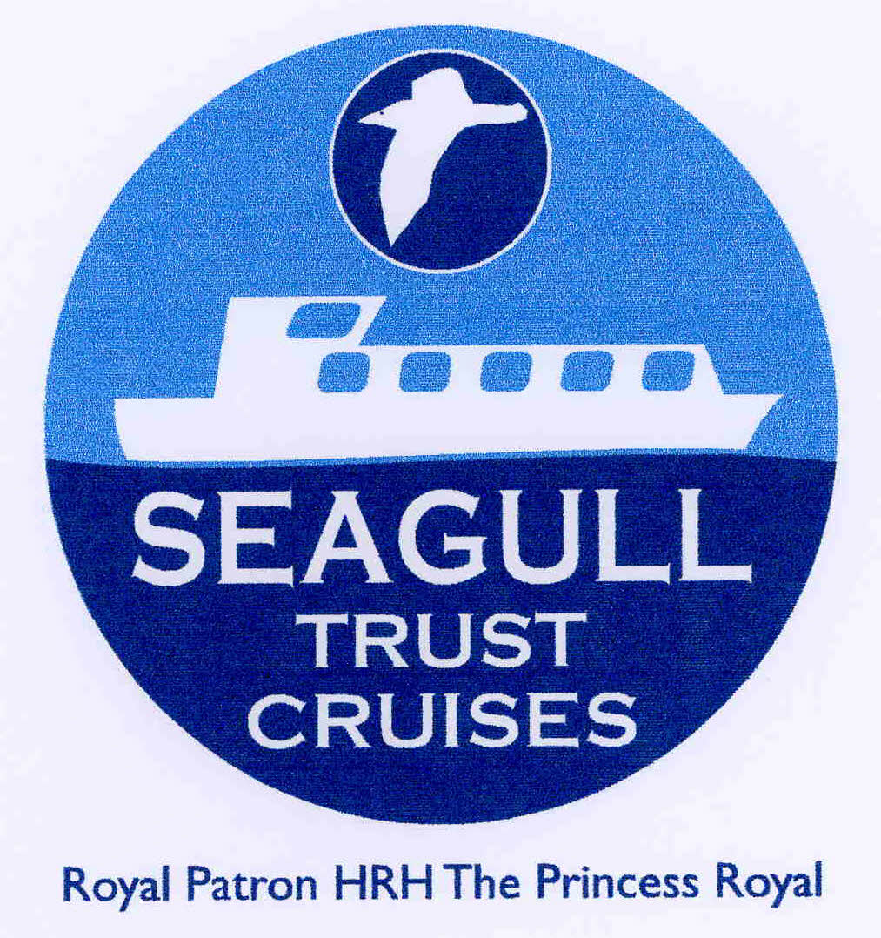

Please complete the form and return to Janice Baillie (Booking Officer) by email: falkirkbookings@seagulltrustcruises.org.uk

Telephone contact can be made at: 07722 342 913

Written confirmation of your booking will be emailed and will include a map and directions to the Boathouse. We hope you enjoy your cruise.

Name of Group
Contact Person: | Name
 | Address
 | Postcode
 | e mail
 | Mobile Phone number

Date required | Time | Cruise No | No of passengers inc helpers | No of wheelchairs  Max 4
Seagull Trust Cruises Scottish Charity Number SC027163
Incorporated in Scotland as a company limited by guarantee Company Number SC179736
STC GDPR Privacy statement is available on the website www.seagulltrustcruises.org.uk
Personal Belongings: - Passengers are responsible for the safekeeping of their own personal belongings and any medical requisites, and we regret that we cannot accept liability for any loss or damage suffered.
Insurance: - We maintain our public liability insurance policy. Organisations should consider whether additional insurance of their own is necessary or desirable.

